Course Code: CSA1557

Course Name: Cloud Computing and Big Data Analytics

M.Gowripriya

192224223

5) Create a simple cloud software application for Mark Sheet Processing System using any Cloud Service Provider to demonstrate SaaS include the necessary fields such as name of the student, Reg no of the student, Subjects , Marks, Average, percentage, rank, overall performance etc.

AIMS:

To create a simple cloud software application for Mark Sheet Processing System using any Cloud Service Provider to demonstrate SaaS.

PROCEDURE:

Step1: Go to zoho.com.

Step 2: Log into the zoho.com.

Step 3: Select one application step.

Step4: Enter application name as GradeHub.

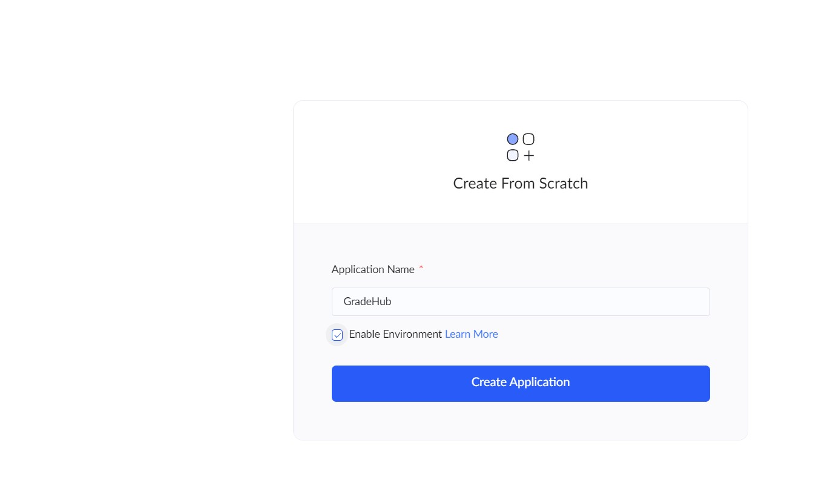

Step 5: Created new application as GradeHub.

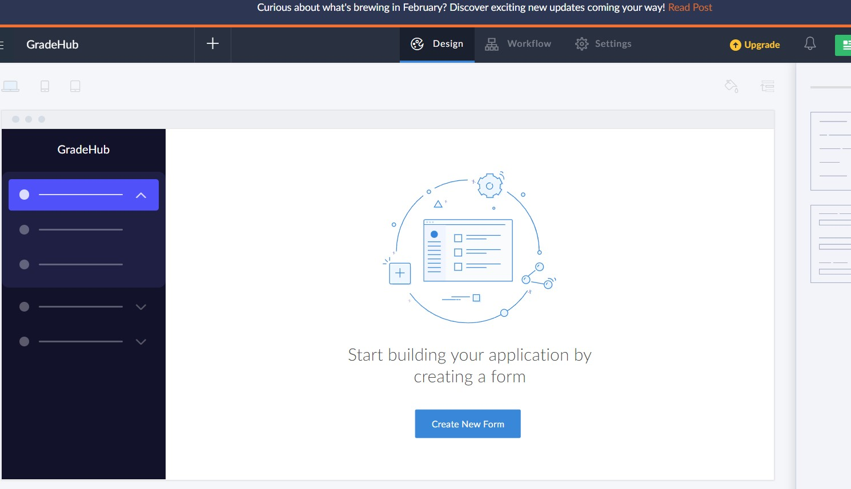

STEP 6: Select from Stratch and Create form as SEM1.

STEP 7: The form has been created as Book

Choose the fields.

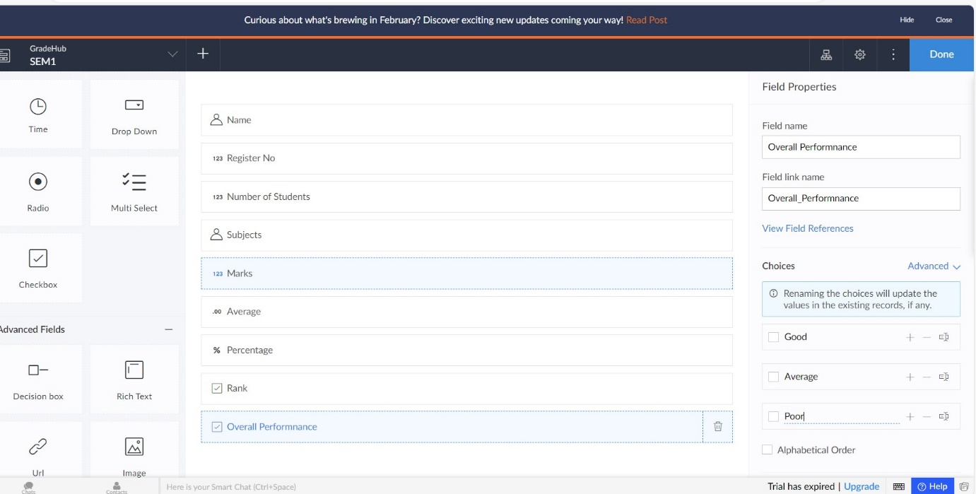

STEP 8: Click Access Development Live

STEP 9: Enter the details of the SEM1.

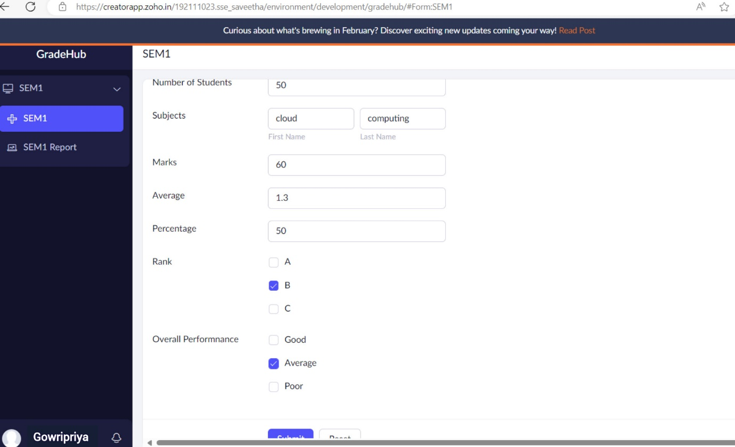

STEP 10: The report has been entered in the SEM1 report.

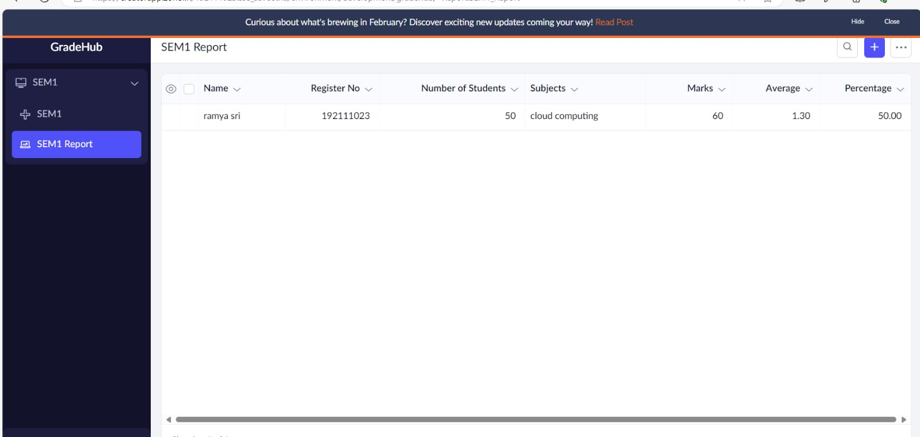

IMPLEMENTATION:

STEP1: GOTO ZOHO.COM

STEP 2: LOGINTOTHE ZOHO.COM

STEP 3: SELECT ONE APPLICATION

STEP 4: ENTER APPLICATION NAME

STEP 5: Created New Application

STEP 6: Select from Stratch and Create form as Property Description.

STEP 7: The form has been created as Property Description

Step 8: Choose the fields.

STEP 9: Click Access Development Live and enter the details to access

STEP 10: The report has been registered in the Property Description report.